**《实况足球2016（PES2016）》妖人推荐 高潜力球员一览**

2015-10-20 17:43:43 来源：实况足球吧 作者：shadowzhl 编辑：Shy夏夏　[我要投稿](http://bbs.gamersky.com/thread-348492-1-1.html)

　　《实况足球2016（PES2016）》妖人就是潜力高的球员，在大师联赛中可以用很低的价钱买来，在经过几个赛季培养就会成为顶级球星的球员，可以成为球队核心，也可以高价出售，那么在实况足球2016有哪些妖人呢？一起来看看妖人推荐吧！

[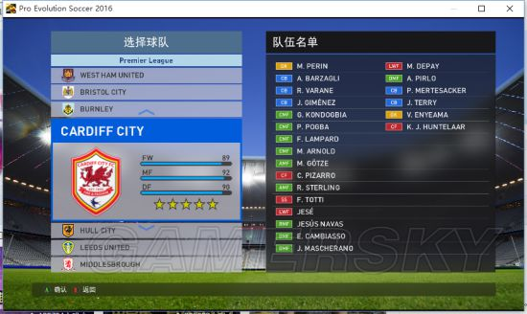](http://www.gamersky.com/showimage/id_gamersky_01.shtml?http://img1.gamersky.com/image2015/10/20151020xdj_9/image001.jpg)

[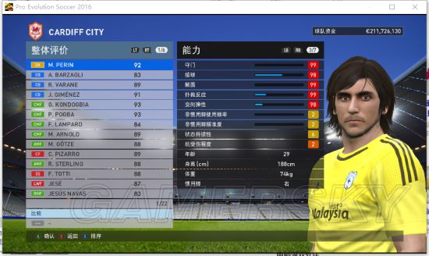](http://www.gamersky.com/showimage/id_gamersky_01.shtml?http://img1.gamersky.com/image2015/10/20151020xdj_9/image003.jpg)

[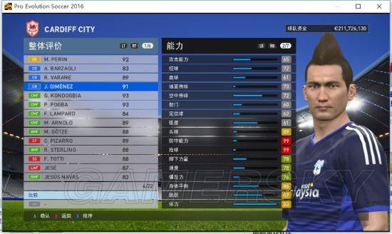](http://www.gamersky.com/showimage/id_gamersky_01.shtml?http://img1.gamersky.com/image2015/10/20151020xdj_9/image005.jpg)

[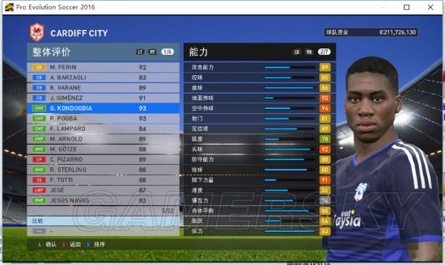](http://www.gamersky.com/showimage/id_gamersky_01.shtml?http://img1.gamersky.com/image2015/10/20151020xdj_9/image007.jpg)

[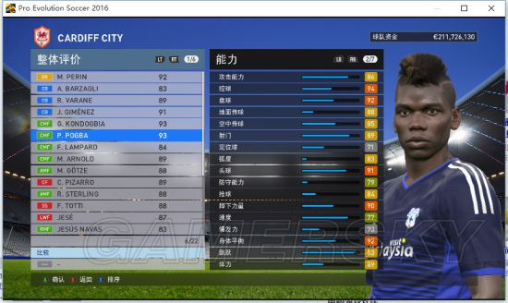](http://www.gamersky.com/showimage/id_gamersky_01.shtml?http://img1.gamersky.com/image2015/10/20151020xdj_9/image009.jpg)

[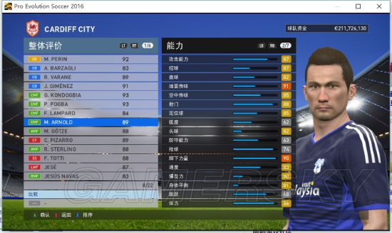](http://www.gamersky.com/showimage/id_gamersky_01.shtml?http://img1.gamersky.com/image2015/10/20151020xdj_9/image011.jpg)

[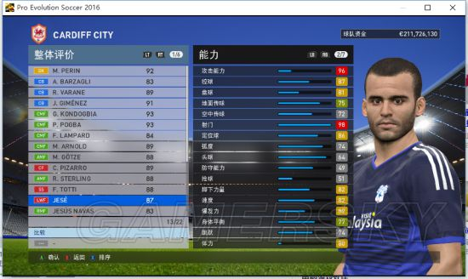](http://www.gamersky.com/showimage/id_gamersky_01.shtml?http://img1.gamersky.com/image2015/10/20151020xdj_9/image013.jpg)

[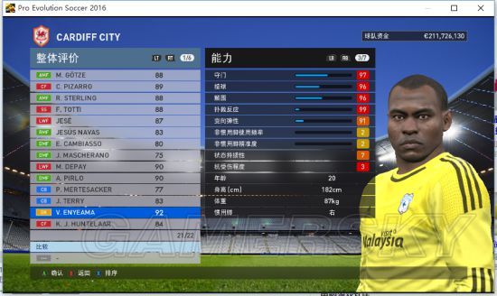](http://www.gamersky.com/showimage/id_gamersky_01.shtml?http://img1.gamersky.com/image2015/10/20151020xdj_9/image015.jpg)